The data contains the following columns: "Last name", "first name", "Score", "Team", "Section". That “Score” could be a percentage (converted to a decimal in this dataset) and "Score" might be the same score in a percentage format out of 100.

To proceed with the descriptive analysis, I'll focus on the "Score" column to calculate quartiles, the interquartile range (IQR), and prepare the data for a box and whisker plot. Let's do that next.

The descriptive analysis of the "Score" column yields the following insights:

- Count: There are 1033 scores in the dataset.

- Mean: The average score is approximately 0.907, which translates to 90.7%.

- Standard Deviation: The scores have a standard deviation of approximately 0.074, indicating the variability from the average.

- Minimum: The lowest score recorded is 0.0 (or 0%).

- 25th Percentile (Q1): The first quartile is at 0.88 (or 88%), meaning 25% of the scores are below this value.

- Median (Q2 / 50th Percentile): The median score is 0.92 (or 92%), indicating that half of the scores are below this value and half are above.

- 75th Percentile (Q3): The third quartile is at 0.96 (or 96%), meaning 75% of the scores are below this value.

- Maximum: The highest score is 1.0 (or 100%).

- Interquartile Range (IQR): The IQR, which measures the middle 50% of the data, is 0.08 (or 8%).

Let's start by performing a descriptive analysis of the scores, including measures like mean, median, standard deviation, and then proceed to generate box and whisker plots for each team's scores.

The descriptive analysis of the dataset reveals the following:

**Overall Score Statistics**

**- Count: 1033 scores**

**- Mean: 0.907 (90.7%)**

**- Standard Deviation: 0.074**

**- Minimum: 0.0 (0%)**

**- 25th Percentile: 0.88 (88%)**

**- Median (50th Percentile): 0.92 (92%)**

**- 75th Percentile: 0.96 (96%)**

**- Maximum: 1.0 (100%)**

By Team Score Statistics

Teams display varying means, suggesting differences in performance levels. Some key observations:

- Team 4 has the highest mean score (0.941, 94.1%), indicating a potentially higher performance level.

- Team 19 has the lowest mean score (0.878, 87.8%), suggesting lower performance on average.

- The standard deviations vary, indicating differing levels of score variability within teams.

These statistics suggest specific trends: certain teams consistently perform higher or lower than others, and there is significant variability within teams.

- Variability: The spread of scores within teams varies, with some teams showing a tight distribution (less variability in scores) and others showing a wider range (more variability). This can be seen from the height of the boxes and the range of the whiskers.

- Median Scores: The line within each box represents the median score for each team. You can observe that while many teams have their median around the same level (close to 0.92), there are exceptions with notably higher or lower medians.

- Outliers: Points that lie outside the whiskers represent outliers. Several teams have scores that are considered outliers on both the lower and higher ends, indicating that there are scores that deviate significantly from the rest.

- High Performing Teams: Team 4, for example, shows high median scores and a compact interquartile range, suggesting consistent high performance with less variability among its members.

- Lower Performing or More Variable Teams: Conversely, teams like Team 19 show either lower median scores or a wider range of scores, indicating either a lower performance or greater variability in performance within the team.

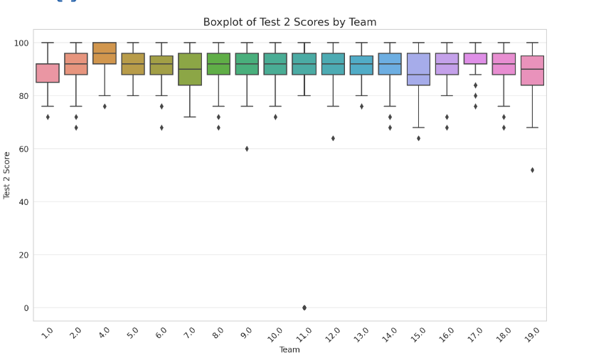Next, I'll generate a boxplot for the " Scores" to compare these trends.

Here are some insights from the data used to plot the chart:

- Team 1 has an average score of approximately 0.894.

- Teams 2 through 19 show a variety of average scores, with Team 17 achieving the highest average score of about 0.928 and Team 19 having the lowest average score of approximately 0.878.

- The scores fluctuate across the teams, indicating differences in performance or scoring criteria applied within different teams.

This visualization helps in identifying how teams compare in terms of average scores, highlighting teams that might require additional support or recognition for their higher performance.

The boxplot for the " Scores" across different teams provides additional insights:

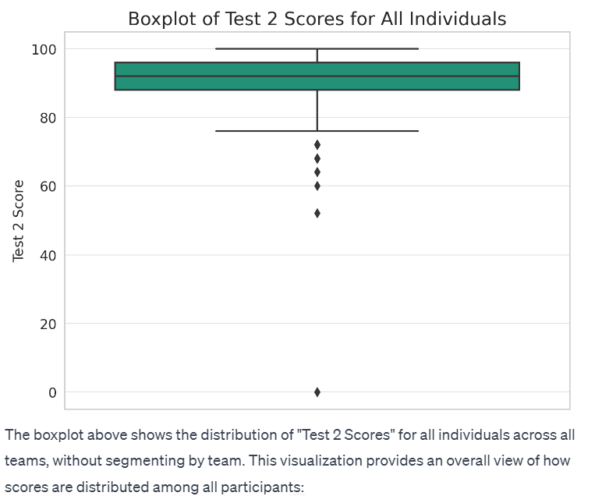- Consistency with Previous Observations: Teams identified as high performing based on the "Score" also tend to show higher performance in "Score". For instance, Team 4 continues to exhibit high median scores and a compact distribution, indicating consistent high performance.

- Median Scores: The median scores for "Score" are similarly positioned across teams as they were for the "Score", with most teams clustering around the same median values, yet there are distinct differences in performance levels among teams.

- Variability and Outliers: Like the "Score", there's noticeable variability within teams for "Score", and outliers are present, indicating scores that significantly deviate from the rest of the team's performance.

- Comparative Performance: Teams that showed lower performance or greater variability in the "Score" boxplot tend to show similar trends in the "Score" boxplot. Team 19, for example, shows a broader range of scores and a slightly lower median, indicating variability and a range of performance levels within the team.

These boxplots visually confirm the trends observed in the descriptive statistics, illustrating differences in performance both within and across teams. High-performing teams tend to have higher median scores and less variability, whereas teams with lower median scores or more outliers show greater variability in performance. These visual and statistical analyses together provide a comprehensive overview of the performance trends among the teams.

The boxplot above shows the distribution of " Scores" for all individuals across all teams, without segmenting by team. This visualization provides an overall view of how scores are distributed among all participants:

- Median: The line within the box indicates the median score, which appears to be around 92, consistent with the descriptive statistics provided earlier.

- Interquartile Range (IQR): The box represents the middle 50% of scores (from the 25th to the 75th percentile), showing where the bulk of scores lie. This range is from approximately 88 to 96, suggesting that most participants scored within this range.

- Whiskers: Extend from the box to show the range of the data, excluding outliers. The range seems to cover from the lowest non-outlier scores to the highest, giving a sense of the overall spread of scores.

- Outliers: Points outside the whiskers indicate scores that are significantly higher or lower than the rest. There are a few outliers on both the lower and higher ends, indicating some scores that deviate from the main body of data.

This plot gives a succinct overview of the performance distribution on Test 2, highlighting the central tendency, variability, and outliers within the scores.